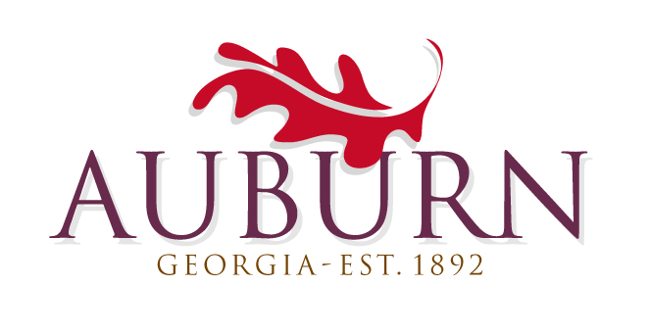

MAYOR
Linda Blechinger

CITY ADMINISTRATOR
Alex W. Mitchem
CITY COUNCIL
Peggy J. Langley
Robert L. Vogel III
Bill Ackworth
Jay L. Riemenschneider
CITY OF AUBURN
MAYOR and CITY COUNCIL
Business Meeting
In COUNCIL CHAMBERS

November 1, 2018

6:00 PM

INVOCATION
PLEDGE
- PUBLIC HEARING – Auburn-Barrow County Millage Rate

COUNCIL REPORTS & ANNOUNCEMENTS

STAFF REPORTS
Police Department- Chief Hodge
Library- Bel Outwater
Storm Water-Joe Moravec
Public Works- Iris Akridge
Parks and Leisure- Michael Parks
Community Development - Jay Miller
City Clerk- Joyce Brown
Administration- Alex Mitchem

NEW BUSINESS
- Citizen Comments on Agenda Items
- Consent Agenda
- October 4, 2018 – Business Meeting Minutes
- October 18, 2018 - Council Workshop Minutes
- October 30, 2018 – Special Called Meeting Minutes
- New Vehicle Purchase/Trade – Chief Hodge
- False Statement Ordinance – Chief Hodge
- Rail Property Rezone – Jay Miller
- Brewery Ordinance – Jay Miller
- Street Light Ordinance – Jay Miller
- Small Cell Right of Way– Alex Mitchem
- Auburn-Barrow County Millage Rate – Joyce Brown
- Citizen Comments

